1. Random Quotes Generator

Onbutton click you need to generate random quote

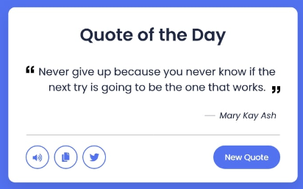

1. Word Scramble Game

Rearranged the words within the given time limit

i.e: elvle 🡺 level

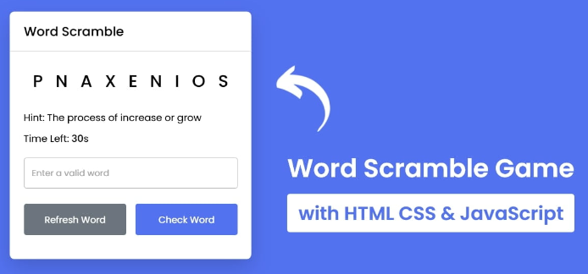

1. Testimonial Slider



1. Basic Image Editor

Brightness saturation, inversion, grayscale

Apply these filters on image editor on input range(Used Classlist add/remove,init(),filter)

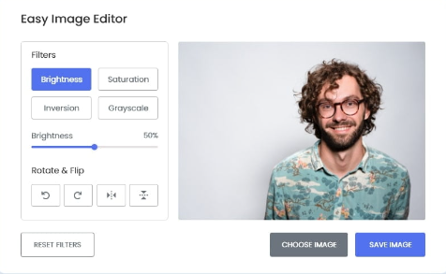

1. Weather App

Used Geolocation and fetch api in this weather app

